UNITED STATES
SECURITIES AND EXCHANGE COMMISSION
Washington, D.C. 20549

SCHEDULE 14A

Proxy Statement Pursuant to Section 14(a) of the
Securities Exchange Act of 1934 (Amendment No. )

☑ | Filed by the Registrant | ☐ | Filed by a party other than the Registrant

CHECK THE APPROPRIATE BOX:
☐ |  | Preliminary Proxy Statement
☐ |  | Confidential, for Use of the Commission Only (as permitted by Rule 14a-6(e)(2))
☐ |  | Definitive Proxy Statement
☑ |  | Definitive Additional Materials
☐ |  | Soliciting Material under §240.14a-12


SL Green Realty Corp.
(Name of Registrant as Specified In Its Charter)
(Name of Person(s) Filing Proxy Statement, if other than the Registrant)

PAYMENT OF FILING FEE (CHECK ALL BOXES THAT APPLY):
☑ |  | No fee required
☐ |  | Fee paid previously with preliminary materials
☐ |  | Fee computed on table in exhibit required by Item 25(b) per Exchange Act Rules 14a-6(i)(1) and 0-11

 |  | Your Vote Counts! Smartphone users Point your camera here and vote without entering a control number For complete information and to vote, visit www.ProxyVote.com Control # V93678-P47034 *Please check the meeting materials for any special requirements for meeting attendance. At the meeting, you will need to request a ballot to vote these shares. SL GREEN REALTY CORP. 2026 Annual Meeting Vote by June 1, 2026 11:59 PM ET You invested in SL GREEN REALTY CORP. and it’s time to vote! You have the right to vote on proposals being presented at the Annual Meeting. This is an important notice regarding the availability of proxy materials for the stockholder meeting to be held on June 2, 2026. Get informed before you vote View the Notice and Proxy Statement, 2025 Annual Report and additional soliciting materials, if any, online OR you can receive a free paper or email copy of the material(s) by making a request prior to May 19, 2026. If you would like to request a copy of the material(s) for this and/or future stockholder meetings, you may (1) visit www.ProxyVote.com, (2) call 1-800-579-1639 or (3) send an email to sendmaterial@proxyvote.com. If sending an email, please include your control number (indicated below) in the subject line. Unless requested, you will not otherwise receive a paper or email copy of these material(s). Vote in Person at the Meeting* June 2, 2026 12:00 P.M., Eastern Time The Auditorium at One Vanderbilt One Vanderbilt Avenue New York, NY 10017 SL GREEN REALTY CORP. ONE VANDERBILT AVENUE NEW YORK, NY 10017
 | 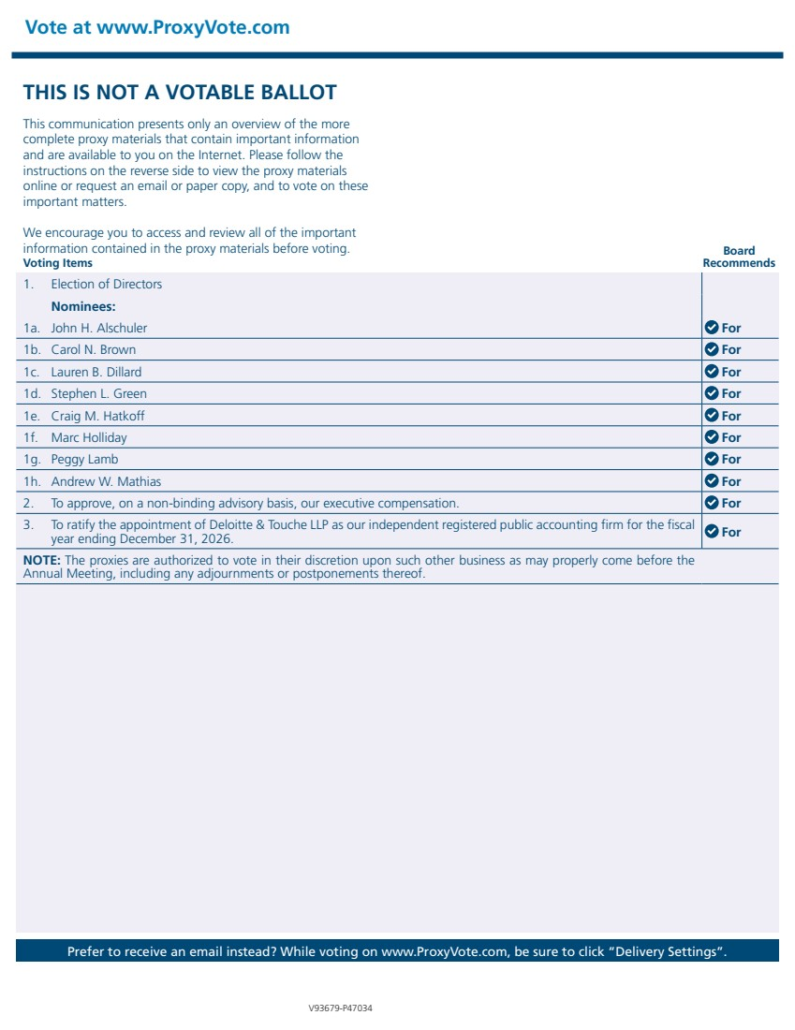 | Vote at www.ProxyVote.com Prefer to receive an email instead? While voting on www.ProxyVote.com, be sure to click “Delivery Settings”. V93679-P47034 Voting Items Board Recommends 1. Election of Directors Nominees: 1a. John H. Alschuler For 1b. Carol N. Brown For 1c. Lauren B. Dillard For 1d. Stephen L. Green For 1e. Craig M. Hatkoff For 1f. Marc Holliday For 1g. Peggy Lamb For 1h. Andrew W. Mathias For 2. To approve, on a non-binding advisory basis, our executive compensation. For 3. To ratify the appointment of Deloitte & Touche LLP as our independent registered public accounting firm for the fiscal year ending December 31, 2026. For NOTE: The proxies are authorized to vote in their discretion upon such other business as may properly come before the Annual Meeting, including any adjournments or postponements thereof. THIS IS NOT A VOTABLE BALLOT This communication presents only an overview of the more complete proxy materials that contain important information and are available to you on the Internet. Please follow the instructions on the reverse side to view the proxy materials online or request an email or paper copy, and to vote on these important matters. We encourage you to access and review all of the important information contained in the proxy materials before voting.

